Merge Sort
Merge Sort — bu samarali va barqaror saralash algoritmi bo‘lib, Divide and Conquer (Bo‘lib Olish va Yengish) tamoyiliga asoslanadi. Bu algoritm massivni rekursiv tarzda ikki bo‘lakka bo‘lib, har bir bo‘lakni alohida saralaydi va oxirida ularni birlashtirib, tartiblangan massivni hosil qiladi.
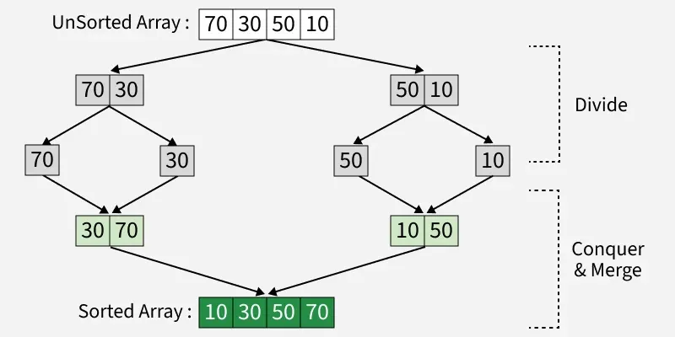
Merge Sort algoritmining ishlash prinsipi:
- Bo‘lish (Divide): Massivni yoki ro‘yxatni rekursiv tarzda ikki bo‘lakka bo‘lib, har bir bo‘lakda faqat bitta element qolguncha bo‘lish davom ettiriladi;
- Yengish (Conquer): Har bir kichik bo‘lak alohida merge sort algoritmi yordamida tartiblanadi;
- Birlashtirish (Merge): Tartiblangan kichik bo‘laklar qaytadan tartiblangan holda birlashtiriladi. Bu jarayon davom etadi, toki har ikkala bo‘lakdagi barcha elementlar birlashtirilguncha.
Merge Sort algoritmi yordamida [38, 27, 43, 10] massivini tartiblash.
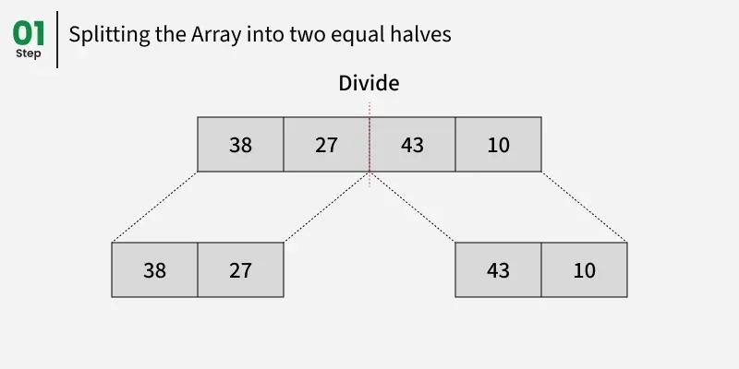
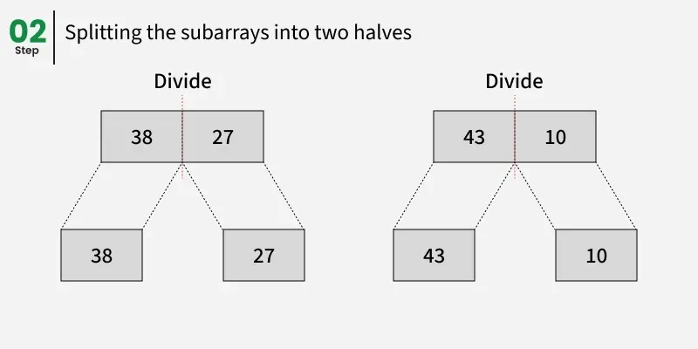
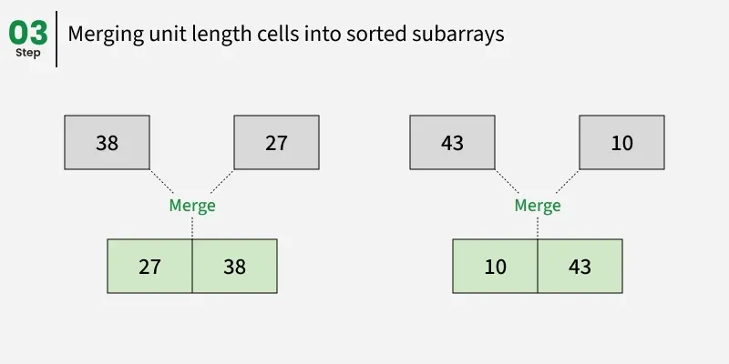
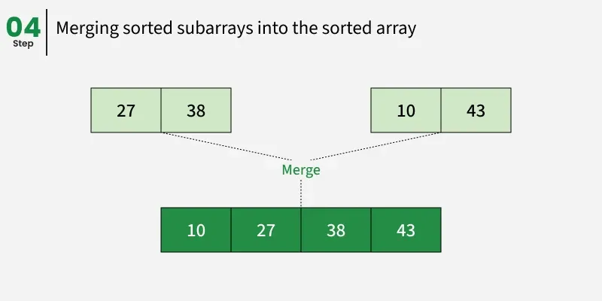
C++ kodi:
#include <iostream>
#include <vector>
using namespace std;

// arr[] ning ikki bo'lagini birlashtiradi.
// Birinchi bo'lak arr[left..mid]
// Ikkinchi bo'lak arr[mid+1..right]
void merge(vector<int>& arr, int left,
int mid, int right){

int n1 = mid - left + 1; // Chap bo'lakning uzunligi
int n2 = right - mid; // O'ng bo'lakning uzunligi

// Yordamchi vektorlar yaratamiz
vector<int> L(n1), R(n2);

// L[] va R[] ga ma'lumotlarni ko'chiramiz
for (int i = 0; i < n1; i++)
L[i] = arr[left + i]; // Chap bo'lakni L ga ko'chiramiz
for (int j = 0; j < n2; j++)
R[j] = arr[mid + 1 + j]; // O'ng bo'lakni R ga ko'chiramiz

int i = 0, j = 0;
int k = left;

// Yordamchi vektorlarni qayta birlashtiramiz
// arr[left..right] ga
while (i < n1 && j < n2) {
if (L[i] <= R[j]) {
arr[k] = L[i];
i++;
}
else {
arr[k] = R[j];
j++;
}
k++;
}

// Agar L[] da qolgan elementlar bo'lsa, ularni ko'chiramiz
while (i < n1) {
arr[k] = L[i];
i++;
k++;
}

// Agar R[] da qolgan elementlar bo'lsa, ularni ko'chiramiz
while (j < n2) {
arr[k] = R[j];
j++;
k++;
}
}

// begin — chap indeks va end — o'ng indeks
// arr ning tartiblanishi kerak bo'lgan bo'lagini ko'rsatadi
void mergeSort(vector<int>& arr, int left, int right){

if (left >= right)
return;

int mid = left + (right - left) / 2; // O'rtadagi indeks
mergeSort(arr, left, mid); // Chap bo'lakni tartiblaymiz
mergeSort(arr, mid + 1, right); // O'ng bo'lakni tartiblaymiz
merge(arr, left, mid, right); // Ikki bo'lakni birlashtiramiz
}

// Dastur kodi
int main(){

vector<int> arr = {38, 27, 43, 10}; // Tartiblanadigan massiv
int n = arr.size(); // Massivning uzunligi

mergeSort(arr, 0, n - 1); // Massivni mergeSort yordamida tartiblaymiz
for (int i = 0; i < arr.size(); i++)
cout << arr[i] << " "; // Tartiblangan massivni chiqarish
cout << endl;

return 0;
}

Python kodi:
def merge(arr, left, mid, right):
n1 = mid - left + 1 # Chap bo'lakning uzunligi
n2 = right - mid # O'ng bo'lakning uzunligi

# Yordamchi massivlarni yaratamiz
L = [0] * n1
R = [0] * n2

# L[] va R[] ga ma'lumotlarni ko'chiramiz
for i in range(n1):
L[i] = arr[left + i] # Chap bo'lakni L ga ko'chiramiz
for j in range(n2):
R[j] = arr[mid + 1 + j] # O'ng bo'lakni R ga ko'chiramiz

i = 0
j = 0
k = left

# Yordamchi massivlarni qayta birlashtiramiz
# arr[left..right] ga
while i < n1 and j < n2:
if L[i] <= R[j]:
arr[k] = L[i]
i += 1
else:
arr[k] = R[j]
j += 1
k += 1

# Agar L[] da qolgan elementlar bo'lsa, ularni ko'chiramiz
while i < n1:
arr[k] = L[i]
i += 1
k += 1

# Agar R[] da qolgan elementlar bo'lsa, ularni ko'chiramiz
while j < n2:
arr[k] = R[j]
j += 1
k += 1

def mergeSort(arr, left, right):
if left < right:
mid = (left + right) // 2 # O'rtadagi indeks

mergeSort(arr, left, mid) # Chap bo'lakni tartiblaymiz
mergeSort(arr, mid + 1, right) # O'ng bo'lakni tartiblaymiz
merge(arr, left, mid, right) # Ikki bo'lakni birlashtiramiz

# Dastur kodi
if __name__ == "__main__":
arr = [38, 27, 43, 10] # Tartiblanadigan massiv

mergeSort(arr, 0, len(arr) - 1) # Massivni mergeSort yordamida tartiblaymiz
for i in arr:
print(i, end=" ") # Tartiblangan massivni chiqaramiz
print()

Merge Sortning Murakkablik Tahlili

Vaqt Murakkabligi:
- Yaxshi holat (Best Case): O(n log n)
  - Agar massiv allaqachon tartiblangan bo‘lsa
- O‘rtacha holat (Average Case): O(n log n)
  - Agar massiv tasodifiy tartiblangan bo‘lsa
- Eng yomon holat (Worst Case): O(n log n)
  - Agar massiv teskari tartibda bo‘lsa

Qo‘shimcha Xotira (Auxiliary Space): O(n)
Merge sort qo‘shimcha xotira talab qiladi, chunki u har bir bo‘lakni tartiblayotganda vaqtincha massivlarni yaratadi. Shu sababli, qo‘shimcha xotira murakkabligi O(n) bo‘ladi. Bu xotira yordamchi massivni saqlash uchun kerak bo‘ladi.
Merge Sortning qo‘llanilishi:
- Katta ma'lumotlarni tartiblashtirish (Sorting large datasets): Merge Sort katta hajmdagi ma'lumotlarni samarali tartiblashtirish uchun ishlatiladi, chunki uning vaqt murakkabligi O(n log n) bo‘lib, juda katta ma'lumotlarni ham tezda tartiblaydi.
- Tashqi tartiblashtirish (External sorting): Agar ma'lumotlar hajmi xotiraga sig‘masa, ya'ni fayl tizimida bo‘lsa, merge sort tashqi tartiblashtirish algoritmi sifatida ishlatiladi. Bu holatda, ma'lumotlar diskda saqlanadi va merge sort yordamida bo‘laklarga ajratilib, ularni birlashtiradi.
- Merge Sort, inversiyalarni hisoblash (Inversion counting), o'ngdagi kichik elementlarni hisoblash (Count Smaller on Right) va Surpasser Count kabi masalalarni samarali hal qilish uchun ishlatiladi.
- Dasturlash tillaridagi kutubxonalarda foydalanish: Merge Sort va uning varianti TimSort Python, Java Android va Swift dasturlash tillarida ishlatiladi. TimSort ko‘proq barqarorlikni ta’minlaydi, bu esa QuickSortda mavjud emas. Java’da Arrays.sort QuickSort’dan foydalanadi, lekin Collections.sort MergeSortni ishlatadi.
- Linked listlarni tartiblash: Merge Sort, Linked listsni tartiblash uchun afzal ko‘rilgan algoritmdir, chunki linked listlarda merge jarayoni oson va samarali bajariladi.
- Parallel ishlash: Merge Sortni parallel ravishda bajarish mumkin, chunki biz har bir sub-massivni mustaqil ravishda tartiblab, keyin ularni birlashtirgan holda tartiblangan massivni hosil qilamiz.
- Ikkita tartiblangan massivning birlashishi va kesishishi: Merge Sortning merge funksiyasi, ikkita tartiblangan massivni samarali ravishda birlashtirish yoki kesish (union and intersection) kabi muammolarni hal qilishda ishlatiladi.

 | MergeSort | acmp.ru ЗАДАЧА №112 Армия  https://acmp.ru/asp/do/index.asp?main=task&id_course=2&id_section=12&id_topic=9&id_problem=48
robocontest.uz Masala #0041 Massiv
https://robocontest.uz/tasks/0041
robocontest.uz Masala # 0075 Inversiyalar soni
https://robocontest.uz/tasks/0075

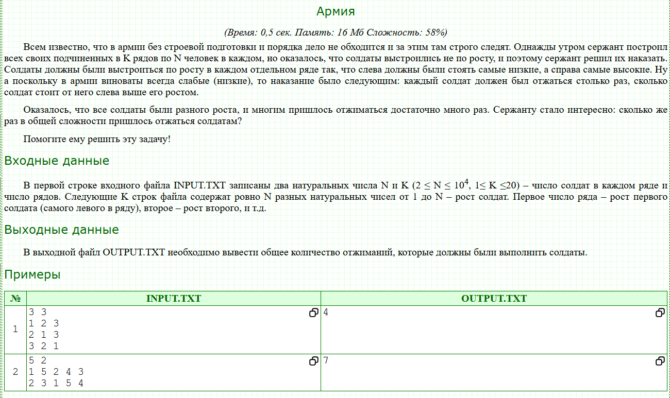

#include <bits/stdc++.h>
using namespace std;

using int64 = long long;

// [l, r) segmentida mergesort va inversiyalarni sanash
static int64 merge_count(vector<int>& a, vector<int>& tmp, int l, int r) {
if (r - l <= 1) return 0;
int m = (l + r) >> 1;
int64 ans = merge_count(a, tmp, l, m) + merge_count(a, tmp, m, r);

int i = l, j = m, k = l;
while (i < m && j < r) {
if (a[i] <= a[j]) {
tmp[k++] = a[i++];
} else {
tmp[k++] = a[j++];
ans += (m - i); // chapda qolganlarning barchasi a[j]-dan katta
}
}
while (i < m) tmp[k++] = a[i++];
while (j < r) tmp[k++] = a[j++];
for (int t = l; t < r; ++t) a[t] = tmp[t];
return ans;
}

int main() {
ios::sync_with_stdio(false);
cin.tie(nullptr);

int N, K;
if (!(cin >> N >> K)) return 0;

vector<int> a(N), tmp(N);
long long total = 0;

for (int row = 0; row < K; ++row) {
for (int i = 0; i < N; ++i) cin >> a[i]; // 1..N bo'lgan turli sonlar
total += merge_count(a, tmp, 0, N);
}

cout << total << '\n';
return 0;
}

#include <bits/stdc++.h>
using namespace std;

using int64 = long long;

// [l, r) kesmada inversiyalarni sanaydi va a[l..r) ni tartiblaydi
static int64 count_inv(vector<int>& a, int l, int r) {
if (r - l <= 1) return 0;
int m = (l + r) >> 1;
int64 ans = count_inv(a, l, m) + count_inv(a, m, r); // chap va o'ng yarmlar tartiblanadi

// Kesishuvchi juftliklar: chap va o'ng yarmlar HOZIR tartiblangan
int i = l, j = m;
while (i < m && j < r) {
if (a[i] <= a[j]) {
++i;
} else {
ans += (m - i); // a[i] > a[j] bo'lsa, i..m-1 hammasi > a[j]
++j;
}
}

// Endi ikkisini bitta tartiblangan segmentga birlashtiramiz
inplace_merge(a.begin() + l, a.begin() + m, a.begin() + r);
return ans;
}

int main() {
ios::sync_with_stdio(false);
cin.tie(nullptr);

int N, K;
if (!(cin >> N >> K)) return 0;

vector<int> a(N);
long long total = 0;

for (int row = 0; row < K; ++row) {
for (int i = 0; i < N; ++i) cin >> a[i]; // 1..N (takrorlanmaydi)
total += count_inv(a, 0, N);
}

cout << total << '\n';
return 0;
}

#include <bits/stdc++.h>
using namespace std;
using ll = long long;

ll merge(vector<int>& v, int left, int mid, int right){
int l = left, r = mid + 1;
vector<int>temp;
ll cnt = 0;
while(l <= mid && r <= right){
if(v[l] <= v[r]){
temp.push_back(v[l++]);
} else {
temp.push_back(v[r++]);
cnt += (mid - l + 1);
}
}
while(l <= mid){
temp.push_back(v[l++]);
}
while(r <= right){
temp.push_back(v[r++]);
}
for(int i = left; i <= right; i++){
v[i] = temp[i - left];
}
return cnt;
}

ll mergeSort(vector<int>& v, int left, int right){
if(left >= right) return 0;
int mid = (left + right) / 2;
ll cnt = mergeSort(v, left, mid);
cnt += mergeSort(v, mid + 1, right);
cnt += merge(v, left, mid, right);
return cnt;
}

int main()
{
ios_base::sync_with_stdio(0);
cin.tie(0);
cout.tie(0);

int n, k;
ll cnt = 0;
cin >> n >> k;
vector<int>v(n);
for(int i = 0; i < k; i++){
for(int j = 0; j < n; j++){
cin >> v[j];
}
cnt += mergeSort(v, 0, n - 1);
}
cout << cnt;
}

Fenvik daraxti usulida

#include <bits/stdc++.h>
using namespace std;

struct Fenwick {
int n;
vector<int> bit;
Fenwick(int n=0): n(n), bit(n+1, 0) {}
void reset(int n_) { n = n_; bit.assign(n+1, 0); }
void add(int idx, int val=1) {
for (; idx <= n; idx += idx & -idx) bit[idx] += val;
}
int sumPrefix(int idx) const {
int s = 0;
for (; idx > 0; idx -= idx & -idx) s += bit[idx];
return s;
}
int sumRange(int l, int r) const { // optional
if (r < l) return 0;
return sumPrefix(r) - sumPrefix(l-1);
}
};

int main() {
ios::sync_with_stdio(false);
cin.tie(nullptr);

int N, K;
if (!(cin >> N >> K)) return 0;

Fenwick fw(N);
long long total = 0; // jami “otjimaniya”lar

for (int row = 0; row < K; ++row) {
fw.reset(N);
long long seen = 0;
for (int i = 0; i < N; ++i) {
int h; cin >> h; // balandlik (1..N, takrorlanmaydi)
int not_taller = fw.sumPrefix(h); // chapdagilardan balandligi = h bo‘lganlar
long long taller_left = seen - not_taller; // balandroqlar soni
total += taller_left;
fw.add(h, 1); // hozirgi askarni “ko‘rildi” deb belgilaymiz
++seen;
}
}

cout << total << "\n";
return 0;
}

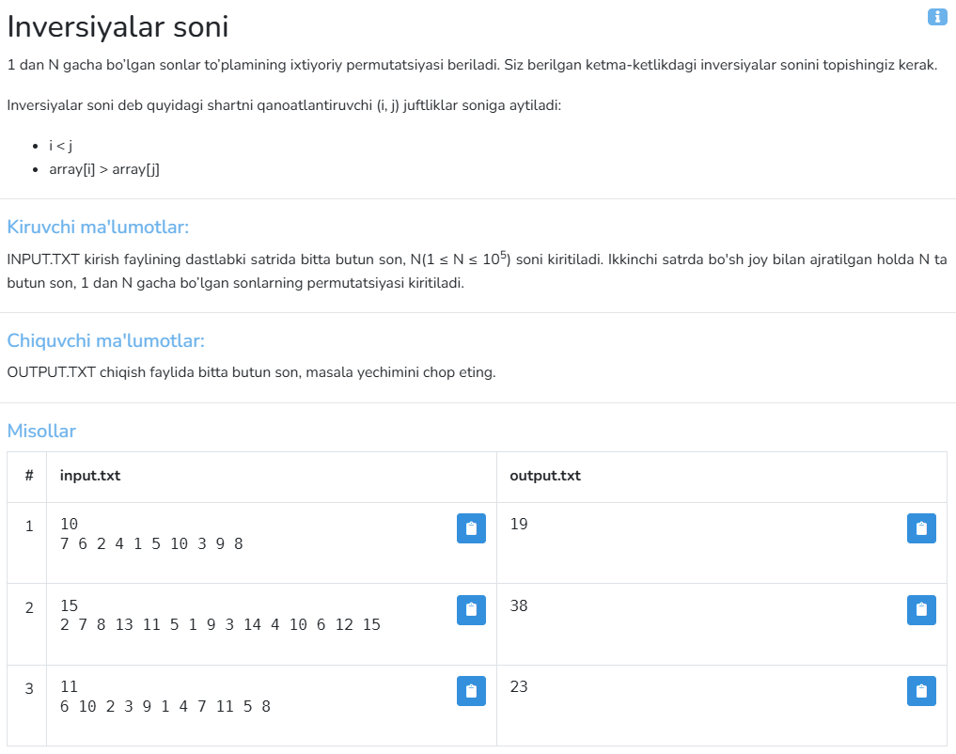
#include <bits/stdc++.h>
using namespace std;
using ll = long long;

ll merge(vector<int>&arr, int left, int mid, int right){
int l = left, r = mid + 1;
ll cnt = 0;

vector<int>temp;
while(l <= mid && r <= right){
if(arr[l] < arr[r]){
temp.push_back(arr[l++]);
} else {
temp.push_back(arr[r++]);
cnt += mid - l + 1;
}
}
while(l <= mid){
temp.push_back(arr[l++]);
}
while(r <= right){
temp.push_back(arr[r++]);
}
for(int i = left; i <= right; i++){
arr[i] = temp[i - left];
}
return cnt;
}

ll mergeSort(vector<int>&arr, int left, int right){
if(left >= right) return 0;
int mid = (left + right) / 2;
ll cnt = mergeSort(arr, left, mid);
cnt += mergeSort(arr, mid + 1, right);
cnt += merge(arr, left, mid, right);
return cnt;
}

int main()
{
int n;
cin >> n;
vector<int>arr(n);
for(int i = 0; i < n; i++){
cin >> arr[i];
}

ll cnt = mergeSort(arr, 0, n - 1);
cout << cnt;
}

#include <bits/stdc++.h>
using namespace std;

using int64 = long long;

// a[l..r) kesmada inversiyalarni sanaydi va shu bo'lakni tartiblaydi
int64 merge_count(vector<int>& a, vector<int>& tmp, int l, int r) {
if (r - l <= 1) return 0;
int m = (l + r) >> 1;
int64 ans = merge_count(a, tmp, l, m) + merge_count(a, tmp, m, r);

int i = l, j = m, k = l;
while (i < m && j < r) {
if (a[i] <= a[j]) {
tmp[k++] = a[i++];
} else {
tmp[k++] = a[j++];
ans += (m - i); // chapda qolganlarning hammasi a[j] dan katta
}
}
while (i < m) tmp[k++] = a[i++];
while (j < r) tmp[k++] = a[j++];
for (int t = l; t < r; ++t) a[t] = tmp[t];

return ans;
}

int main() {
ios::sync_with_stdio(false);
cin.tie(nullptr);

int N;
if (!(cin >> N)) return 0;
vector<int> a(N);
for (int i = 0; i < N; ++i) cin >> a[i];

vector<int> tmp(N);
cout << merge_count(a, tmp, 0, N) << '\n';
return 0;
}

Fenvik daraxti usulida

#include <bits/stdc++.h>
using namespace std;

struct Fenwick {
int n;
vector<int> bit; // 1..n
Fenwick(int n=0): n(n), bit(n+1, 0) {}

// i ga +v qo'shish
void add(int i, int v=1) {
for (; i <= n; i += i & -i) bit[i] += v;
}

// 1..i oraliq yig'indisi
long long sum(int i) const {
long long s = 0;
for (; i > 0; i -= i & -i) s += bit[i];
return s;
}
};

int main() {
ios::sync_with_stdio(false);
cin.tie(nullptr);

int N;
if (!(cin >> N)) return 0;

vector<int> a(N);
for (int i = 0; i < N; ++i) cin >> a[i]; // bu – 1..N permutatsiya

Fenwick fw(N);
long long inv = 0;

// O'ngdan chapga yuramiz: har bir a[i] uchun undan kichiklari soni – sum(a[i]-1)
for (int i = N - 1; i >= 0; --i) {
inv += fw.sum(a[i] - 1);
fw.add(a[i], 1);
}

cout << inv << '\n';
return 0;
}

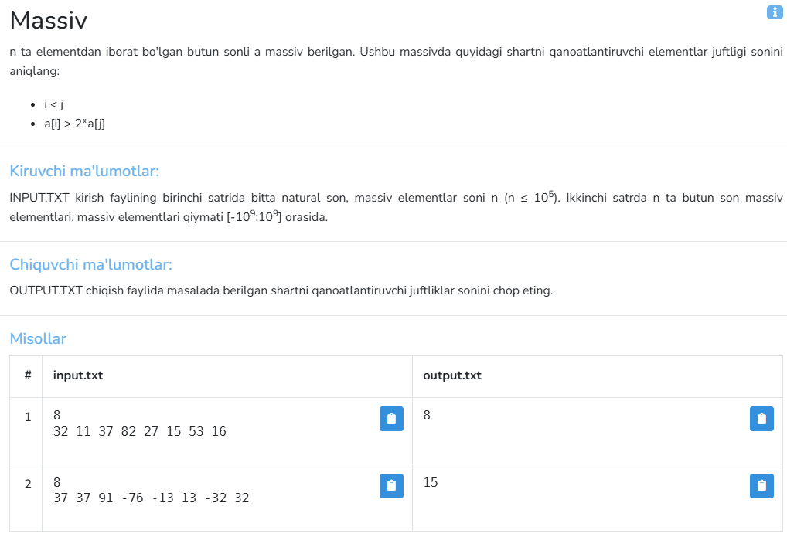

#include <bits/stdc++.h>
using namespace std;
using ll = long long;

ll merge(vector<int>&arr, int left, int mid, int right){
int l = left, r = mid + 1;
ll cnt = 0;
for(int i = l; i <= mid; i++){
while(r <= right && arr[i] > 2LL * arr[r]){
r++;
}
cnt += (r - (mid + 1));
}
r = mid + 1;
vector<int>temp;
while(l <= mid && r <= right){
if(arr[l] < arr[r]){
temp.push_back(arr[l++]);
} else {
temp.push_back(arr[r++]);
}
}
while(l <= mid){
temp.push_back(arr[l++]);
}
while(r <= right){
temp.push_back(arr[r++]);
}
for(int i = left; i <= right; i++){
arr[i] = temp[i - left];
}
return cnt;
}

ll mergeSort(vector<int>&arr, int left, int right){
if(left >= right) return 0;
int mid = (left + right) / 2;
ll cnt = mergeSort(arr, left, mid);
cnt += mergeSort(arr, mid + 1, right);
cnt += merge(arr, left, mid, right);
return cnt;
}

int main()
{
int n;
cin >> n;
vector<int>arr(n);
for(int i = 0; i < n; i++){
cin >> arr[i];
}

ll cnt = mergeSort(arr, 0, n - 1);
cout << cnt;
}

#include <bits/stdc++.h>
using namespace std;

using ll = long long;

long long countPairs(vector<long long>& a, int l, int r) {
if (r - l <= 1) return 0; // [l, r)
int m = (l + r) / 2;
long long ans = countPairs(a, l, m) + countPairs(a, m, r);

// count cross pairs: i in [l, m), j in [m, r)
int j = m;
for (int i = l; i < m; ++i) {
while (j < r && a[i] > 2LL * a[j]) ++j;
ans += (j - m);
}

// merge step
inplace_merge(a.begin() + l, a.begin() + m, a.begin() + r);
return ans;
}

int main() {
ios::sync_with_stdio(false);
cin.tie(nullptr);
int n;
if (!(cin >> n)) return 0;
vector<long long> a(n);
for (int i = 0; i < n; ++i) cin >> a[i];
cout << countPairs(a, 0, n) << "\n";
return 0;
}

Fenvik daraxti usulida

#include <bits/stdc++.h>
using namespace std;

struct Fenwick {
int n;
vector<int> bit; // 1..n
Fenwick(int n=0): n(n), bit(n+1, 0) {}
void add(int i, int v=1) { // pozitsiyaga +v qo'shish
for (; i <= n; i += i & -i) bit[i] += v;
}
long long sum(int i) const { // 1..i yig'indisi
long long s = 0;
for (; i > 0; i -= i & -i) s += bit[i];
return s;
}
};

int main() {
ios::sync_with_stdio(false);
cin.tie(nullptr);

int n;
if (!(cin >> n)) return 0;
vector<long long> a(n);
for (int i = 0; i < n; ++i) cin >> a[i];

// Kompressiya uchun qiymatlar ro'yxati: a[i] va 2*a[i]
vector<long long> all;
all.reserve(2*n);
for (int i = 0; i < n; ++i) {
all.push_back(a[i]);
all.push_back(2LL * a[i]);
}
sort(all.begin(), all.end());
all.erase(unique(all.begin(), all.end()), all.end());

Fenwick fw((int)all.size());
long long ans = 0;
long long seen = 0; // hozirgacha qo'shilgan elementlar soni

for (int j = 0; j < n; ++j) {
// > 2*a[j] bo'lgan ko'rilganlar soni = seen - count(<= 2*a[j])
int idx2 = upper_bound(all.begin(), all.end(), 2LL * a[j]) - all.begin(); // 0-based count
long long notGreater = fw.sum(idx2); // <= 2*a[j]
ans += (seen - notGreater);

// Hozirgi a[j]ni BITga qo'shamiz
int pos = int(lower_bound(all.begin(), all.end(), a[j]) - all.begin()) + 1; // 1-based
fw.add(pos, 1);
++seen;
}

cout << ans << '\n';
return 0;
}

